Traveling Sounds
How does sound travel through a house? There are many doors and walls that the sound waves must bounce off and navigate through. How are sound waves able to permeate these obstacles?
How are difficult-to-observe sound waves similar to easy-to-see water waves?

Avatar: Making Waves

Sound Travels
Arnold: I was in the living room talking to my sister about my weekend plans when my mom appeared in the doorway and said, “Oh no, you won’t!” How was she able to hear us talking from the other room? Don’t walls block the sound of our voices? I know there is a doorway, but it's so small compared to the walls. I didn’t think the sound could travel that way.
Concept Review
Before you dive into the water waves investigation, review some concepts that are key to this upcoming activity.

Galleria

Constructive interference

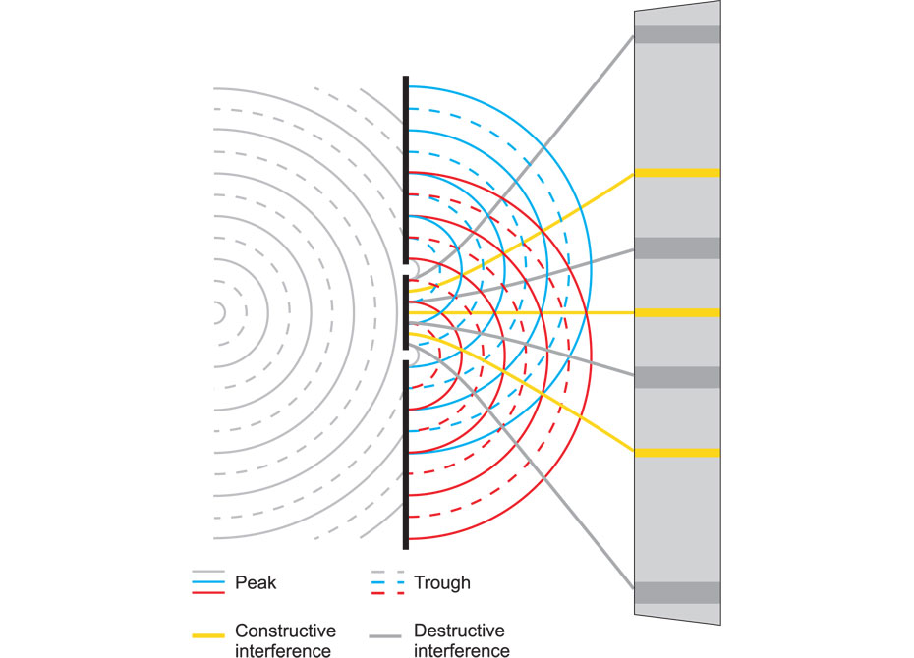
Diagram showing the interaction of two waves with yellow lines to represent constructive interference

Constructive interference occurs when the crests of two waves meet. The crests add to one another, creating a larger amplitude crest. This can occur when two troughs meet as well. When this occurs, water waves look larger.

Destructive interference

Diagram showing the interaction of two waves with gray lines to represent destructive interference

Destructive interference occurs when the crest of one wave meets the trough of another wave. The waves cancel each other, reducing the amplitude at that moment. When this occurs, water waves look smaller or even disappear.

Diffraction

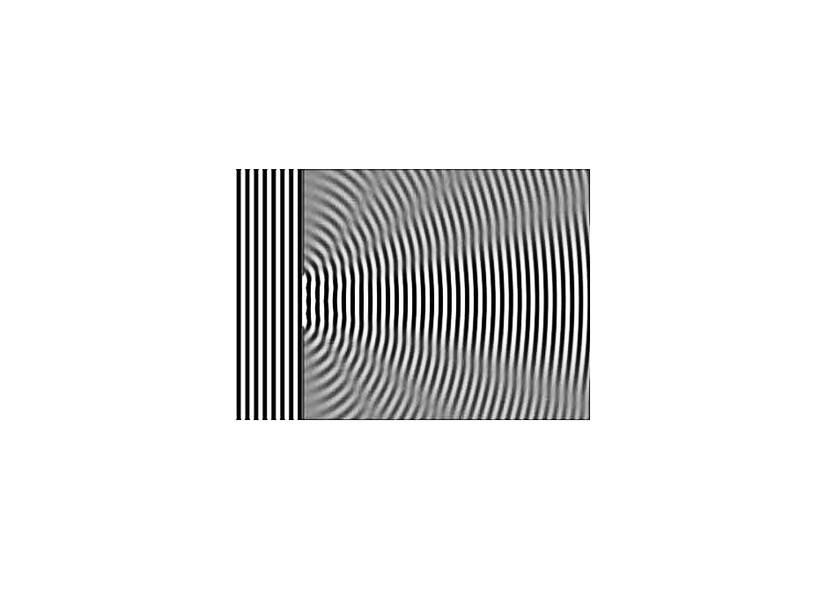
Diagram of interacting waves (shown in black, white, and gray) to show how a wave bends

Diffraction occurs when a wave encounters an obstacle. The wave bends around the obstacle.

Water waves

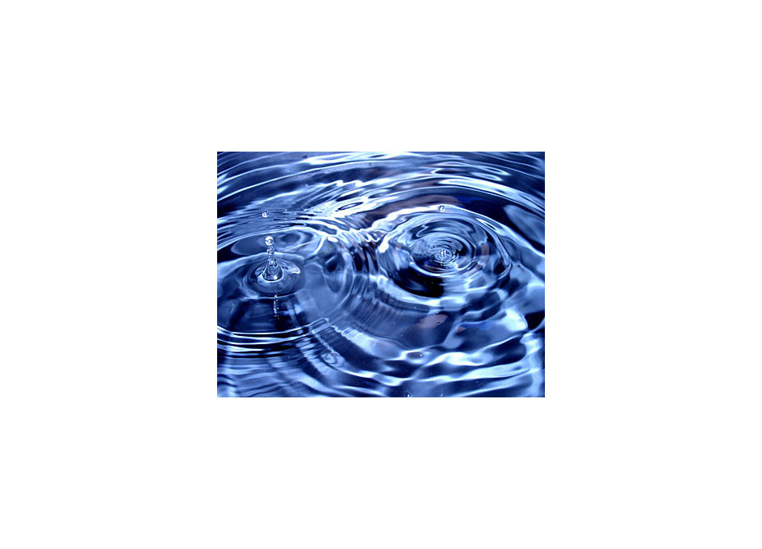
Photograph of water drops hitting a water’s surface

Water waves are surface waves. The energy of the wave moves both parallel and perpendicular to the motion of the wave.

Making Waves
While sound waves are difficult to visually observe, water waves are much easier to see. In this activity, you will use the surface waves of water to observe wave motion, interference between two waves, and diffraction of waves. This investigation simulates the way that sound waves behave.



Drawing Observations
Sometimes words are not enough to describe an observation; then it is more useful to draw what you observe. When recording your data as a drawing, follow these guidelines.

- Use labels: You are recording data so that others can understand what you see, so it's important to label your drawing carefully.
- Remember the scale: Sometimes things are smaller or more complex than you can draw them. It's okay to enlarge these things in your drawings to show details. Just remember that all items in your drawings should be on the same scale so that you present an accurate representation of your observations.
- Keep it organized: You can also include drawings in a data table. To do this, include two columns in your table. One column will give a description of the conditions of the drawing, and the second column will include the drawing itself.

Study Club: Water Wave Activity

Screen 1

Collecting Materials

Picture of glass casserole dish, two glasses, two pennies and a ruler

Khianna: To conduct the water wave activity, the first thing I did was collect the appropriate materials.

Screen 2

1 penny – 15 cm above water

Picture of a penny held 15 cm above the clear pan with water.

Khianna: Then I placed the clear pan on top of the white paper and filled the pan two-thirds of the way with water. Then I held the penny about 15 cm above the center of the pan. When I dropped the penny, I looked at the shadows created on the white paper and recorded my observations.

Screen 3

2 pennies – 15 cm above water

Picture of two pennies held 15 cm above the pan with water. A picture of a penny held above the clear pan with two glasses and water in the pan

Khianna: I held two pennies about 10 cm apart, each 15 cm above the pan. I dropped each penny into the water at the same time, watching as the two waves met each other, and recorded my observations.

Finally, I placed the two glasses in the shallow pan of water, 1 cm apart. I then held one penny 15 cm above the shallow pan and in front of the glasses. I dropped the penny into the water and observed the ripples as the waves reached the glasses and went through the slit.

Condition 1
Here are Khianna's notes and observations for Condition 1.

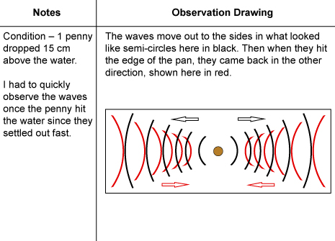

Condition 2
Here are Khianna's notes and observations for Condition 2.

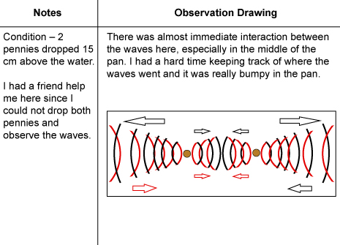

Condition 3
Here are Khianna's notes and observations for Condition 3.

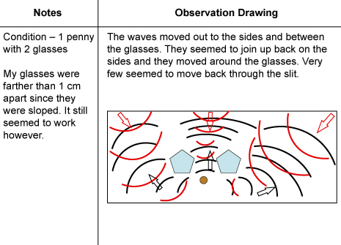

Assignment: Water Waves Investigation
Use the descriptions and the drawings created to answer the questions in this assignment.
Check the rubric to see how you will be graded.

